Novel silica/poly(2,6-dimethyl-1,4-phenylene oxide) hybrid anion-exchange membranes for alkaline fuel cells.

**Abstract**

Poly (2,6-dimethyl-1,4-phenylene oxide) (PPO) based organic inorganic cross-linking hybrid membranes with enhanced chemical stability were prepared using triethylamine (TEA) as quaternization reagent; N,N-dimethyl-3-(trimethoxysilyl)-1-propanamine (TPMS) and Aminopropyltrimethoxysilane (APMS) as the crosslinking agent, respectively. Compared with the non-crosslinked membrane, the crosslinked PPO membranes displayed significantly enhanced mechanical properties, improved dimensional stabilities as well as high conductivities. The APMS crosslinked membranes with 10% silica content exhibited high hydroxyl (OH-) conductivity: 15.3-41.3 mS cm-1 in the temperature range 30-80 ℃. Other favorable properties for fuel cell application include high tensile strengths up to 20MPa and large ion-exchange capacities in the range 2.11 – 2.32 mmol g-1. The membrane was stable in 1 M KOH at 80 ℃ for more than 200 h.

**Keywords:** Anion exchange membrane, Organic-inorganic hybrid membrane, Silane

**1. Introduction**

Comparedwith proton exchange membrane fuel cells (PEMFCs), alkaline polymer electrolyte fuel cells (APEFCs) have shown numerous advantages due to the favorable kinetics of oxygen reduction in high PH conditions and reduced dependence on noble metal catalysts[1-4]. Alkaline anion exchange membranes (AEMs) are the key components of APEFCs[5]. Therefore, membranes are often a key factor in determining the efficiency and lifetime of fuel cells and the performance of APEFCs depend on property of AEMs[6,7].

In recent years, AEMs have drawn many attentions of researchers. The main challenges in the current AEM research is to develop membranes not only with high OH- conductivity, but also with good mechanical properties and chemical stability[8]. High performance APMFCs have been tested with alkaline membranes based on radiation-grafted partially fluorinated poly(ethylene-co-tetrafluoroethylene) films[9] and fully fluorinated poly(hexafluoropropylene-co-tetrafluoroethylene) films[10], which have high conductivities (up to 0.06 S cm-1 at 60 ℃). However, some of their properties need further optimization, such as the unsuitable mechanical properties and high cost.

Meanwhile, non-fluorinate polymer electrolytes have been developed for application in AMFCs, based on polyvinyl alcohol (PVA)[11], polyethersulfones, poly(phthalazinon ether sulfone ketone)[12], polysulfone and poly(2,6-dimethyl1,4-phenylene oxide) (PPO)[13-15]. To overcome the inherent disadvantages of these polymers (mechanical, thermal, and chemical stabilities) the polymers have been modified by physical blending[16], chemical functionalization[17], and crosslinking[18]. A more recently developed modification method is incorporation of inorganic components into polymers to form organic-inorganic hybrid membranes[19].

Mesoporous silica materials with high specific surface area, tunable pore size, and rich morphology have received considerable attention as potential electrolyte membrane materials[20]. However, because of their inherent insolubility and infusibility, silica materials are difficult to process. Additionally, poor distributions of amorphous silica nanoparticles and weak interfacial contacts between amorphous silica nanoparticles and the polymer matrix can result in defects and reduce membrane performance[21]. Consequently, improving the compatibility between the silica nanoparticles and the polymer matrix is critical to increase the comprehensive performance and durability of the polymer electrolyte membranes[22].

Based on the above. In this study, a novel silane coupling agent with pendent amine groups was chosen as crosslinker to synthesis crosslinked AEM. The ammonium on the silane coupling agent improve membrane’s hydrophilia and provide activity groups to transport OH- which significantly improve electrical property of membrane. Meanwhile, the inorganic part of crosslinker strengthen AEM’s mechanical performance[23, 24] and chemical stability.

Furthermore, we discussed the affection of positions of the ammonium groups in crosslinked structure on chemical stability. Crosslinkers with similar structure will exhibit different chemical stability because of different positions of ammonium in the crosslinking structure. We used N, N– dimethyl-3-(trimethoxysilyl)–1-propanamine (TPMS) and Aminopropyltrimethoxysilane (APMS) as two kinds of crosslinkers. They from different crosslinking structure in the membranes and their influences on membranes properties are discussed.

**2. Experimental**

**2.1 Materials**

PPO was [purchase](http://dict.youdao.com/w/eng/purchase/" \l "keyfrom=dict.basic.discriminate)d from Aldrich. Chlorobenzene and N-methyl pyrrolidone were achieved from Tianjin Damao chemical reagent factory in China. 2,2-azobisisobutyronitrile (AIBN) (it was recrystallized from ethanol before use) and N-bromosuccinimide (NBS) were obtained from Beijing Bailingwei Technology Co., Ltd. Triethylamine (TEA), N,N-dimethylacetamide (DMAc) and N-methyl pyrrolidone(NMP) were [purchase](http://dict.youdao.com/w/eng/purchase/" \l "keyfrom=dict.basic.discriminate)d from Tianjin Yongda Chemical Reagent company. N,N–dimethyl-3-(trimethoxysilyl)–1-propanamine, Trimethyl[3-(trimethoxysilyl)-propyl]-ammonium Chloride (ca. 50% in Methanol) and Aminopropyltrimethoxysilane were purchased from J&K Scientific.

**2.2 Synthesis of brominated PPO**

Brominated PPO (BPPO) was synthesized by bromomethylation of polyphenylene (PPO) with NBS[25]. The procedure of the bromomethylation reaction was as summarized in Fig.1: PPO (10.0 g, 56.3 mmol) and chlorobenzene (250 mL) were added into 500 mL three-neck flask. After forming a uniform and transparent solution through stirring, 16.4 g NBS was added into the flask as the bromination reagent. Then the reaction was carried out at 80℃ for 6 h in the oil bath meanwhile dropwise added 1 ml of 0.5 mol/l AIBN solution every half hour. This reaction was carried out under reflux and nitrogen protection using recrystallized AIBN as the initiator. After the reaction, the mixture was rapidly poured into ethanol and got the yellow floc. After standing for 24 hours and suction filtration, the product was dried in an oven at 35℃.

计算机生成了可选文字:
AIBN NBS 
Bromination 

Fig.1 The synthesis of BPPO

**2.3 Preparation of hybrid membranes**

The hybrid membranes were prepared via the solution casting method. The preparation process as shown in Fig.2: 0.3 g (1.64 mmol) BPPO was initially dissolved in 5 ml DMAC and 5 ml NMP mixed solvent through magnetic stirring at room temperature. Then different amount of TEA(160 ul, 152 ul, 144 ul, 136 ul, 128 ul) was added dropwise at 60 ℃ and the reaction was continued for 3 hours. After that two kinds of crosslinkers (TPMS and APMS) was added to from different crosslink structure. After continuously stirring for 3 hours, the mixture was filtered and cast onto a glass plate. The solvent was evaporated in an oven at 80 ℃ for 24 h. After soaking in room temperature 1 mol L-1 NaOH for 48 h, crosslinked membrane in the OH- form was obtained. The membrane was washed thoroughly and immersed in deionized water for 36 h to remove residual NaOH. TPMS cross-linked membranes are named as P1/xSi and APMS cross-linked membranes are named as P2/xSi. Where x represent percentages of silica content. Non-crosslinked membranes are named as P0.



Fig.2 The preparation of hybrid membranes based on PPO

**2.4 Measurements**

1H NMR spectra of PPO-Br were recorded on a Bruker DMX-300 NMR instrument at 300 Hz with CDCl3 used as solvent. Fourier transform infrared (FTIR) spectra of the hybrid membranes were recorded on a VERTEX70 FTIR spectrometer. The thermal properties of the hybrid membranes were conducted by thermogravimetric analysis (TGA, HT/808, METTLERTOLEDO) with a heating rate of 10℃ min-1, respectively in air atmosphere. The water uptake and swelling ratio were determined by measuring the weight and length of dry and hydrated membranes. Water uptake of the membranes was calculated from Eq.(1):

Water uptake (%) = (1)

Where Ww is the weight of hydrated membranes and Wd is the weight of dry membranes. The water swelling ratio of the hybrid membranes are calculated from Eq.(2) and (3):

Area swelling ratio (%) = (2)

Volume swelling ratio (%) = $\left[\left(V_{w}- V_{d}\right)/ V_{d}\right] ×100$ (3)

Where Sw and Vw are the area of wet membranes and Sd and Vd are the volume of dry membranes respectively.

The conductivity of the membranes was measured with a four-probe conductivity cell with a frequency about 3 kHz in deionized water[26]. The mechanical properties of the membranes was measured using a tensile strength instrument (CMT6502, SANS Company, China) at room temperature[27].

**3. Results and discussion**

**3.1 Characterization of BPPO**

1H-NMR spectrum of BPPO is shown in Fig.3. In the spectrum, the resonance at around 4.3 ppm is attributed to the methylene group in benzyl bromide and the characteristic peaks around 2.0 ppm are assigned to methyl groups according to the literature[28, 29]. The ratio of -CH2Br in BPPO could be calculated from Eq(4):

Substitution of BPPO (%) = (4)

Where SCH2 and SCH3 are the area of the peak at 4.3 ppm and 2.0 ppm respectively. The substitution of BPPO is 30%.

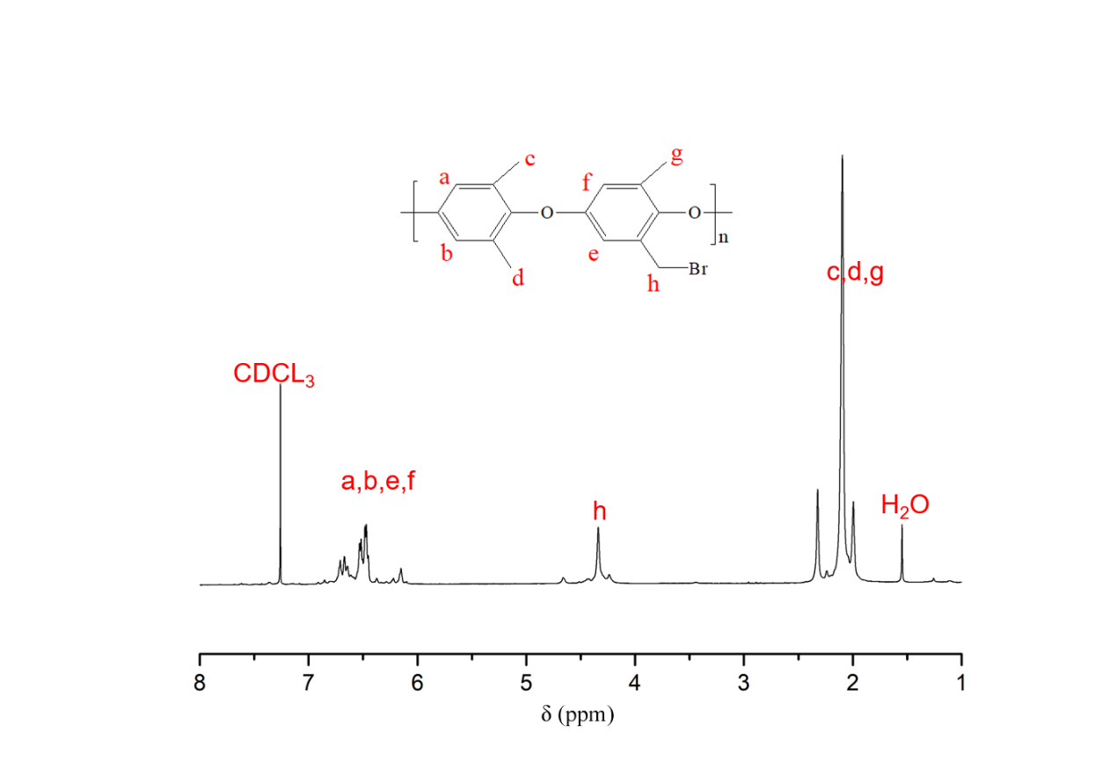

Fig.3 1H NMR spectra of BPPO in CDCl3

**3.2 FTIR spectra of membranes**

FTIR spectra of membranes P0, P1, P2 are shown in Fig.4. All the spectra show a large band between 3100 cm-1 and 3700 cm-1, which is ascribed to the stretching vibration of -OH groups from Si-OH groups and absorbed water. The bands in the 2850-2900 cm-1 region and at 1465 cm-1 are from the stretching of CH3-,-CH2- and =CH- groups. The brand at 1610 cm-1 is attributed to the c=c stretching vibration in phenyl groups.

The vibrations at 1094 cm-1 and 951 cm-1 in P1 and P2 membranes are assigned to the stretching frequency of the Si-O-Si and silanol groups, respectively, indicating the presence of the Si-O-Si cross-linked network in the membranes.

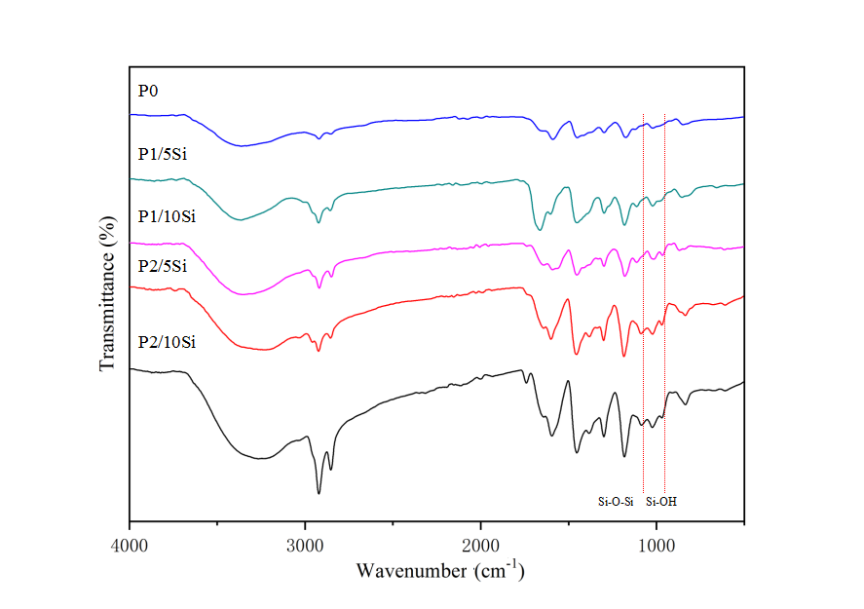

Fig.4 FTIR spectra of P0, P1 and P2 membranes

**3.3 Morphologies of hybrid membranes**

The morphologies of P1 and P2 membranes (surface and cross-section), were observed using SEM and are presented in Fig.5. The morphologies membrane are visibly compact, smooth, and homogenous which is attributed to the favorable interaction between the organic PPO and inorganic silica phases via covalent bonds and weak bonds (such as van der Waals, hydrogen and ionic interactions [30]).

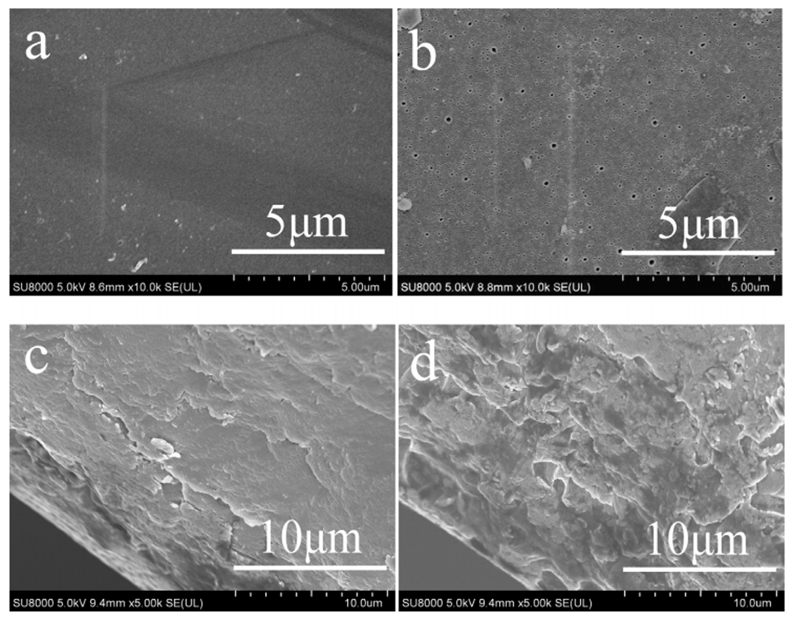

Fig.5 SEM micrographs of (a) P1 surface, (b) P2 surface, (c) P1 cross-section, (d) P2 cross-section

**3.4 Water uptake, swelling ratio and Ion exchange capacity (IEC)**



Dimensional stability and ion exchange capacity is crucial for AEMs. The water uptake, swelling ratio and ion exchange capacity of membranes are show in Table 1. It’s obviously that non-crosslinked membrane had higher swelling degree and bigger IEC. It verified the conclusion which is that crosslinker combines with polymer chains and make polymer tighter[31, 32]. As for water uptake, membranes which contain 5% Si had higher water uptakes than P0 membrane, because of hydrophilic Si-O-Si cross-linked network. Si-O-Si cross-linked network has confrontational affections on membrane’s hydrophilia. On the one side hydrophilic Si-O bonds help membranes to absorb more water, but on the other side cross-linked network will make it harder to absorb water.

Table 1 the water uptake, swelling ratio and ion exchange capacity of membranes

|  |  |  |  |  |  |  |
| --- | --- | --- | --- | --- | --- | --- |
| Membrane | WU (%) | Swelling (%) | |  | IEC (mmol g-1) | |
| Area | Volume |  | Measured | Theoretical |
| P0 | 127.3 | 97.5 | 177.0 |  | 2.66 | 3.58 |
| P1/5Si | 133.6 | 91.2 | 122.1 |  | 2.01 | 2.88 |
| P1/10Si | 105.1 | 80.1 | 117.4 |  | 1.55 | 2.56 |
| P2/5Si | 141.5 | 90.1 | 112.1 |  | 2.11 | 2.54 |
| P2/10Si | 93.6 | 66.5 | 78.5 |  | 1.84 | 2.51 |

**3.5 Conductivity**

Hydroxide conductivity is a major parameter of AEMs. Four-point probe conductivity measurements were carried out to determine the anionic conductivity for the exchanged membrane at different temperature, results are shown in Fig.6. The ion conductivity of all of membrane increased when temperature increased from 30 ℃ to 80 ℃ because the high temperature caused the molecules to move faster and improve the kinetics of electrochemistry. P1 and P2 membranes which contain 5% silica have higher conductivity values than P0 membrane, indicating certain levels of silica content can enhance ionic conductivity. Membrane which contain 10% silica have lower conductivity values than P0 membrane, indicating cross-linked network may inhibits the membrane from conducting ions.

Influence of inorganic silica component on membrane conductivity is confrontational. On the one hand, cross-linked Si-O-Si network may limit the mobility of the conductive ions and hinder the formation of conductive and hydrophilic ionic clusters and channels. Therefore, a decrease in ion conductivity on membrane contains 10% silica has been found. On the other hand, hydroxyl groups such as -SiOH from silica have strong bonding ability with H2O molecules and are thus favorable for water retention and ion transfer. Therefore membranes contain 5% silica have highest conductivity value.

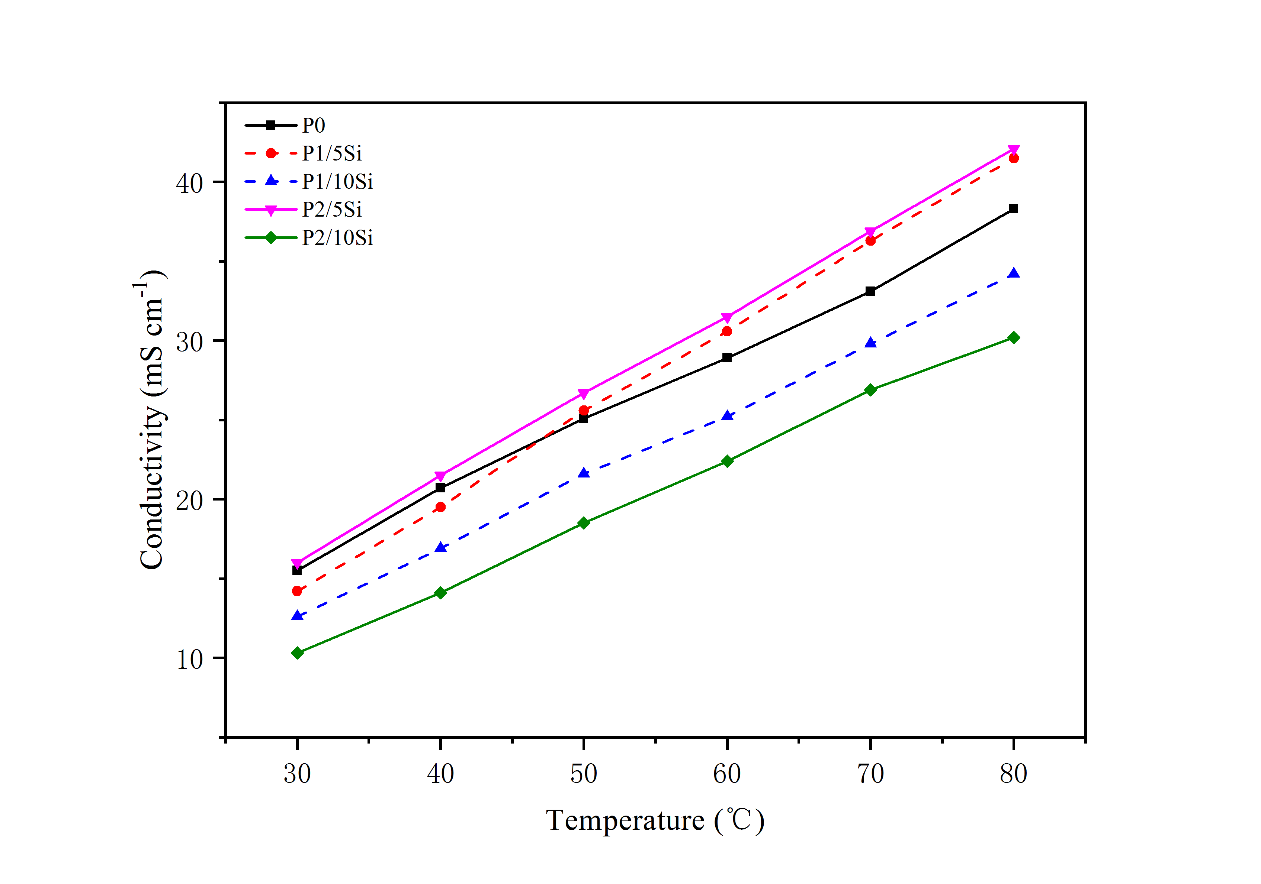

Fig.6 The conductivities of different crosslinked hybrid membrane

**3.6 Alkaline stability**

The alkaline stability of the hybrid membrane in 1 mol L-1 NaOH at 80 ℃ were analyzed by conductivity change (Fig.7). The conductivity of P0 membrane decreased rapidly. After 200 hours soaking in alkaline solution, the conductivity of it only remain 9.5 mS cm-1 at 80 ℃ (which is 25% of its initial level). Notably, the degradation pathway of the QA groups occurred through substitutional displacement and El Elimination[33,34]. Hybrid crosslinking membrane have more stable performance (P1/10Si membrane degraded 55% and P2/10Si membrane only degraded 37%.) which is attributed to crosslink structure between polymer chains because it can protect quaternary ammonium from OH- attack[35].

In addition, the difference between P1 membrane and P2 membrane is the position of quaternary ammonium groups in their crosslink structure. In P1 crosslinked membrane the QA groups were directly grafted on polymer chains, meanwhile in P2 crosslinked membrane the QA groups were disperse in Si-O-Si crosslink structure. Therefore, when QA groups were attacked by OH-, The crosslink structure of P1 membrane will degrade and its integrity will be damaged. As for QA groups in P2 membrane, they will degrade too, but their degradation didn’t influence the crosslink structure. After soaking in alkaline solution, the crosslink structure of P2 membrane remained intact but the crosslink structure of P1 membrane detached from polymer chains because of the degradations of QA groups. Therefore, P2 membranes are more stable than P1 membrane in alkaline circumstance.

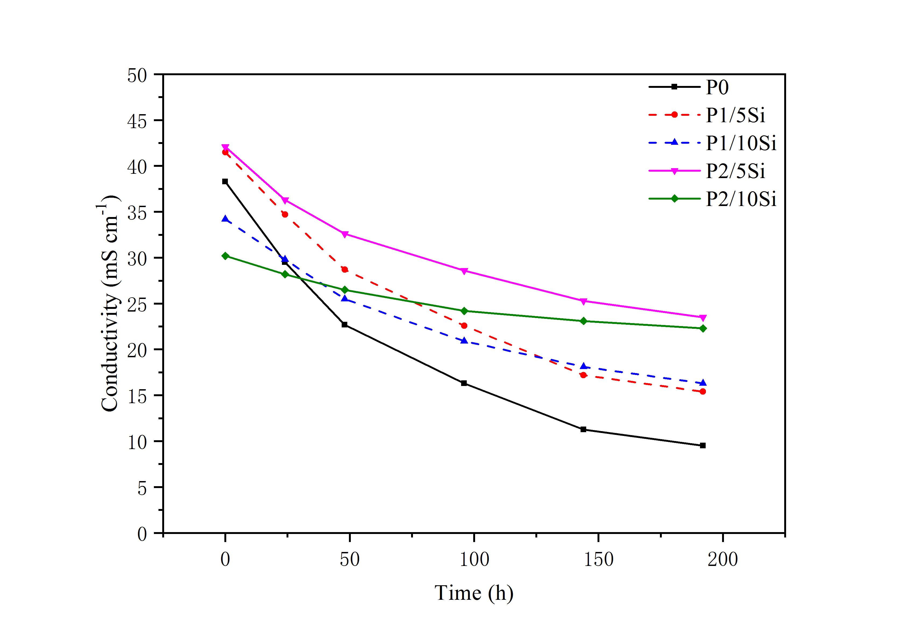

Fig.7 Time-resolved hydroxide conductivity of crosslinked hybrid membranes in 1 M KOH solution at 80 ℃

**3.7 Mechanical properties and thermal properties**

Good mechanical and thermal properties are crucial for AEMs[36]. The mechanical properties are shown in Fig.8 and Fig.9. The tensile strength was 12.1 MPa, 18.1 MPa, 13.2 MPa and 22.4 MPa for P1/5Si, P1/10Si, P2/5Si and P2/10Si respectively, which are all superior than P0 membrane, which is attributed to the formation of the cross-linked Si-O-Si structure in hybrid membranes. As reported, the crosslinked membranes are in general mechanically superior in terms of tensile strength and stiffness, as compared with the non-crosslinked ones.

TGA was used to determine the short-term thermal stabilities of membranes, and the thermograms are presented in Fig.9. The weight loss below 100 ℃ was attributed to the evaporation of absorbed water or residual solvent in membranes. The weight loss between 200 ℃- 400 ℃ was attributed to the decomposition of quaternary ammonium groups. And the weight loss higher than 400 ℃ is caused by the decomposition of the polymer chains. The temperature of 5% weight loss for hybrid membranes is up to 310 ℃, higher than that of P0 membrane (153 ℃). It indicates that Si-O-Si cross-linked network improved thermal stability of membranes.

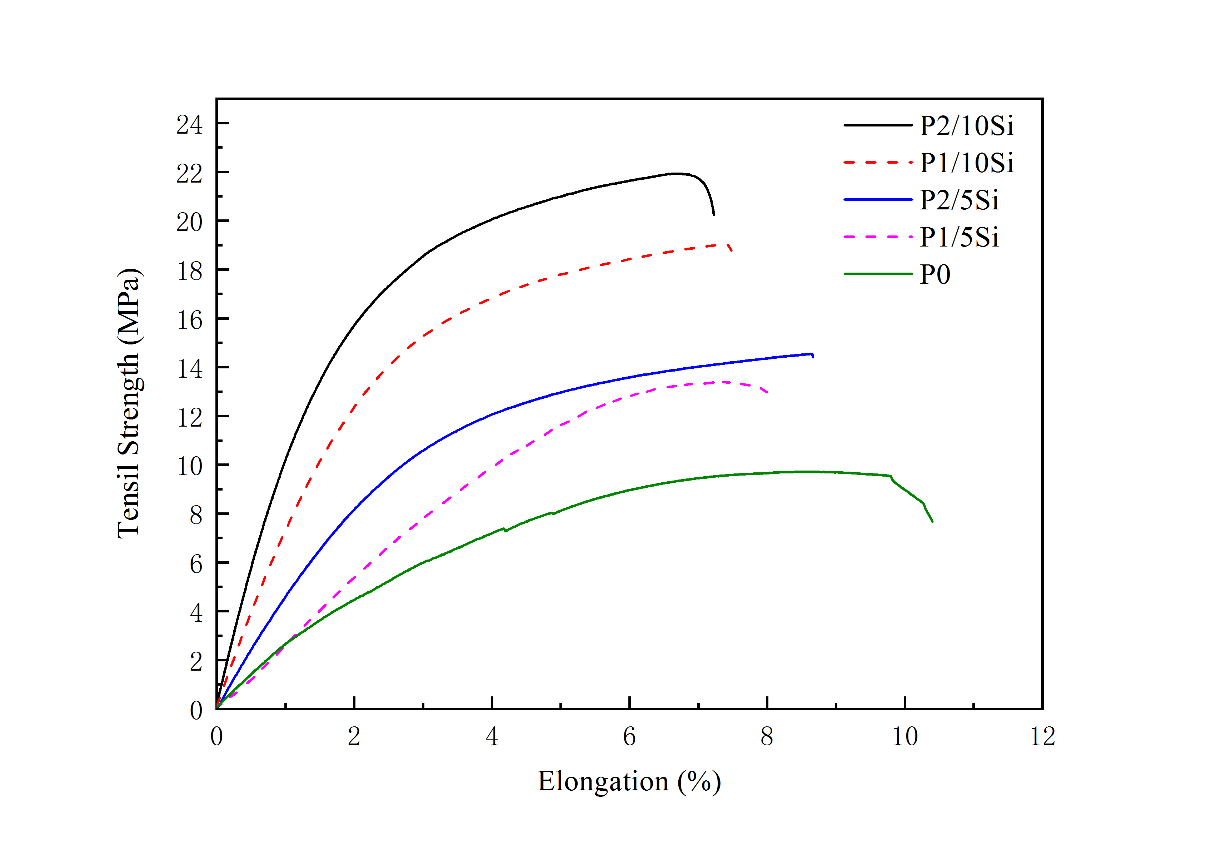

Fig.8 The tensile strength and elongation at break values of membranes

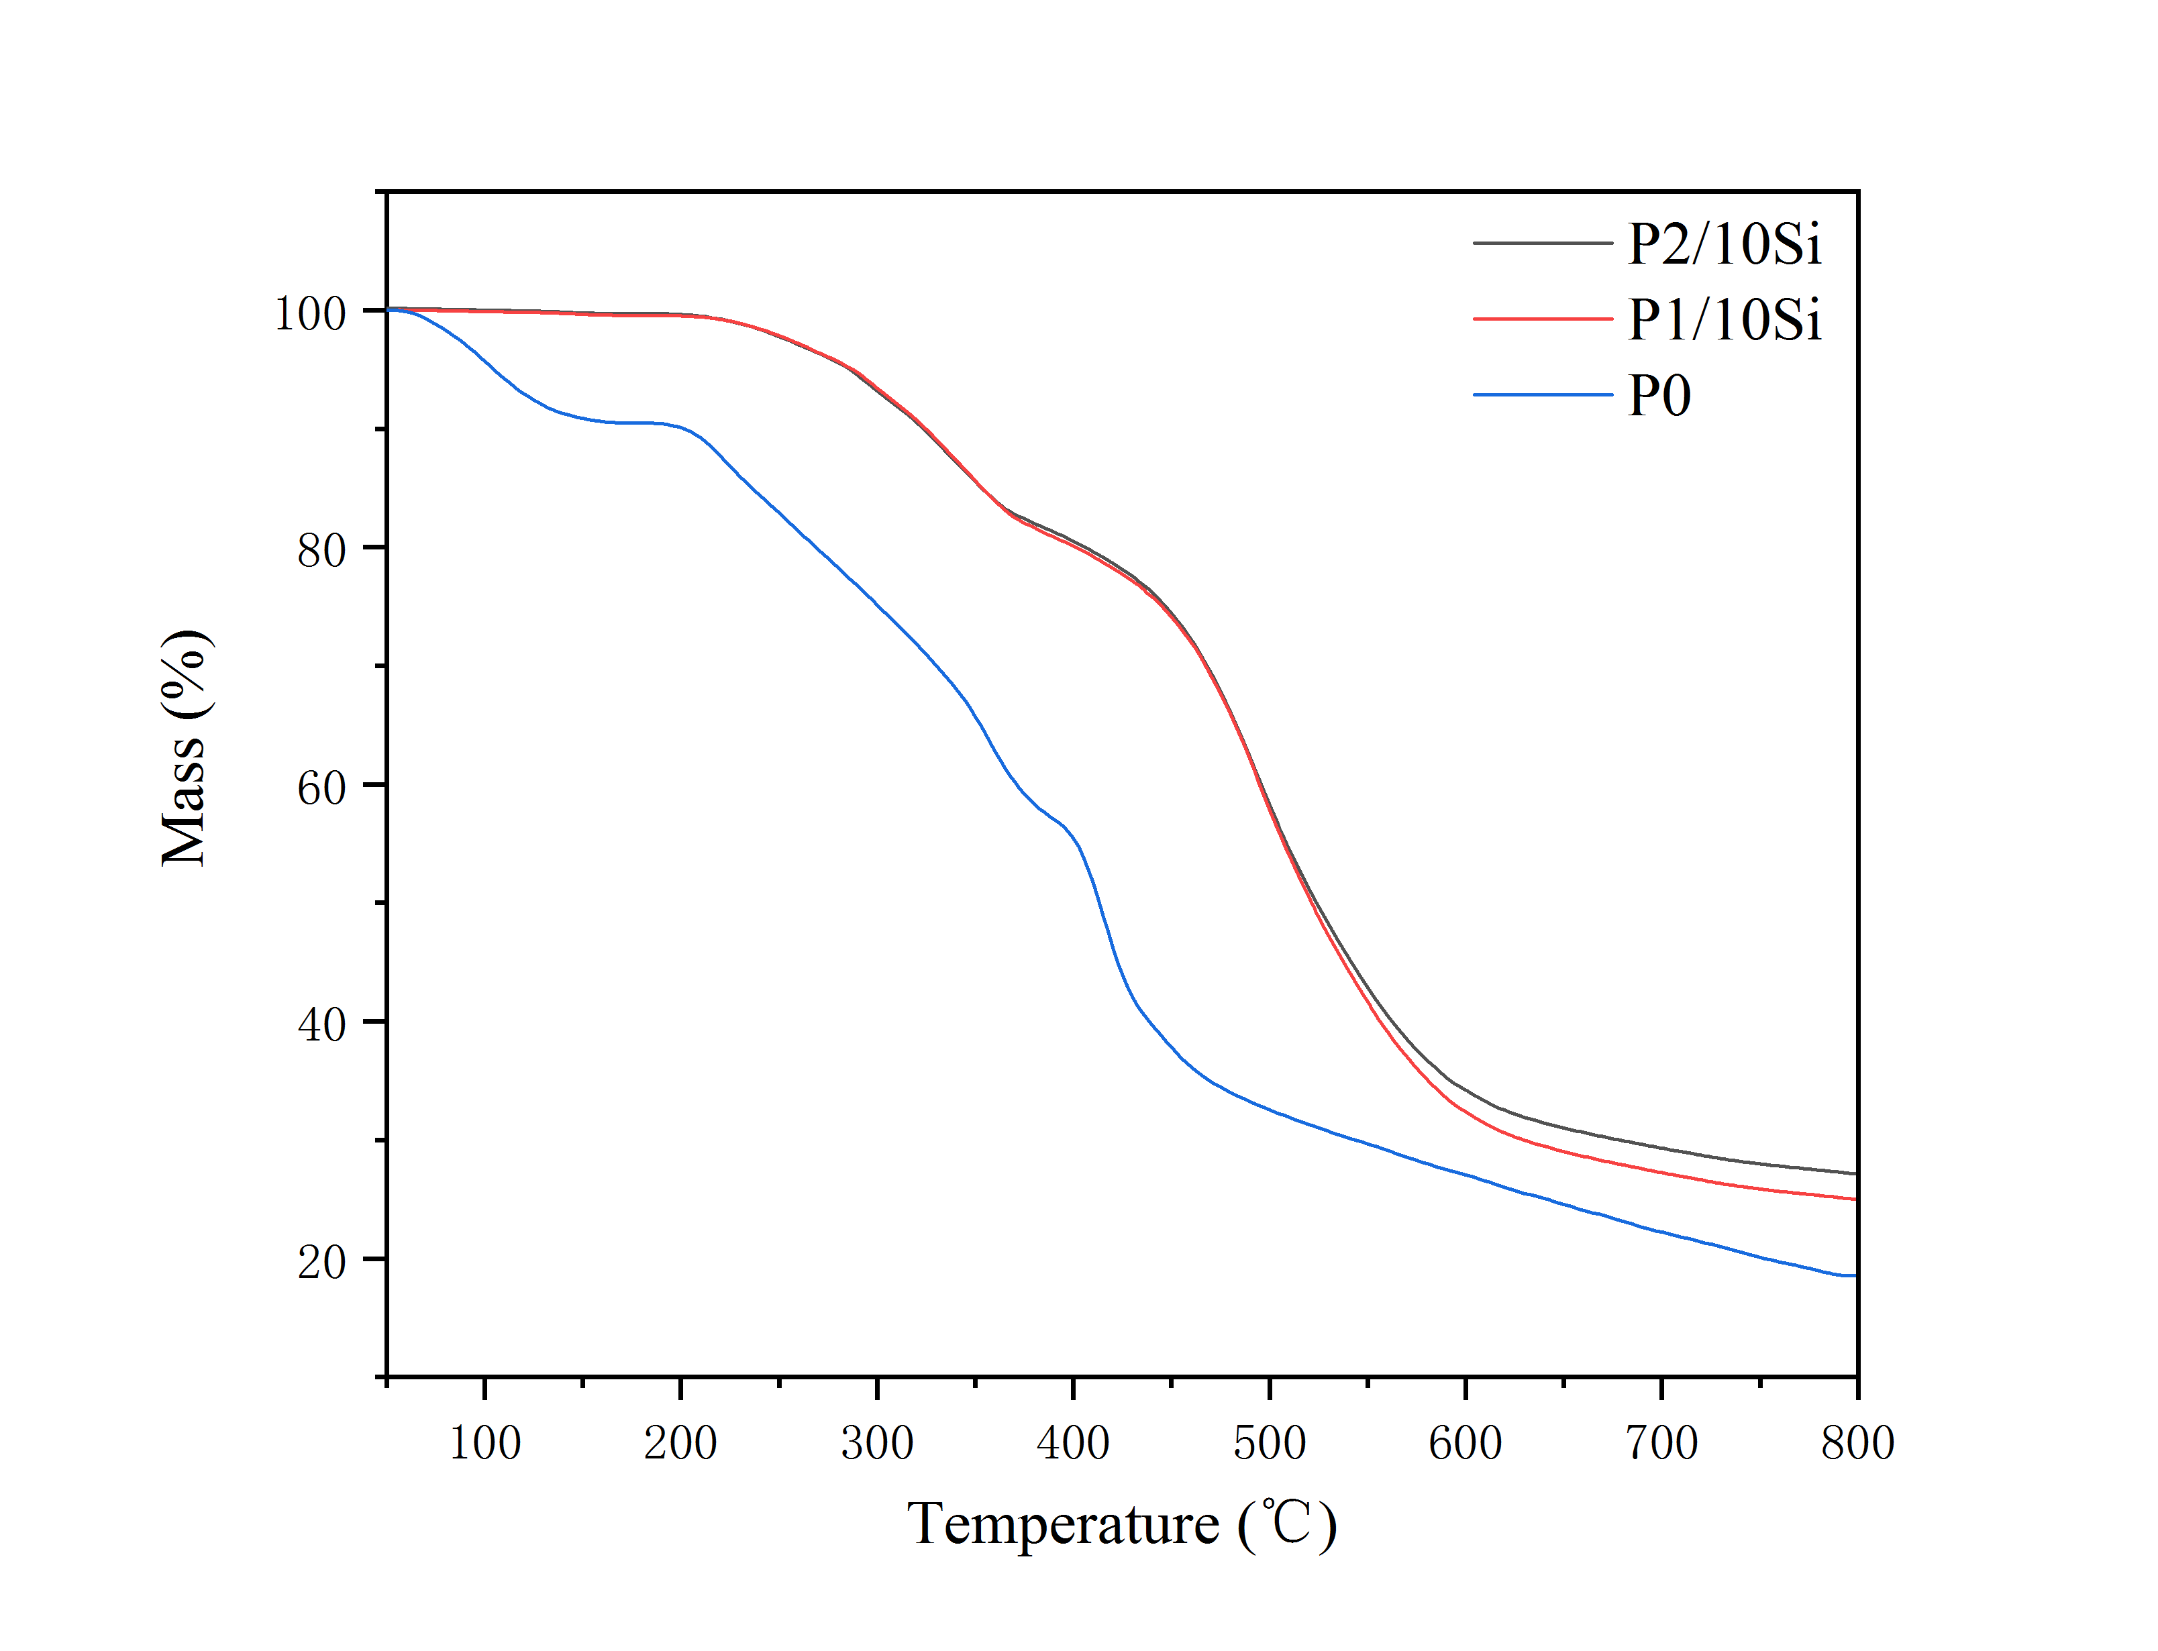

Fig.9 Thermograms of P0, P1 and P2 membranes under air flow with a heating rate of 10 ℃ min-1

**4. Conclusions**

Quaternized polymer membranes with crosslinked structures were fabricated using siloxane compounds as the crosslinker. 1H NMR and FTIR results indicated that silica content and TEA were successfully grafted onto the polymer and the siloxane network structure was formed as well. The hybrid membranes were uniform according to SEM images. The TGA data indicated that the prepared membranes were thermally stable up to 300 ℃. The swelling of crosslinked membranes gradually decreased with the increase of the crosslinking agent. Compared with the non-crosslinked membrane, the mechanical properties and chemical stability of the crosslinked membranes were significantly enhanced. And APMS crosslinked membranes were more stable than TPMS crosslinked membranes in alkaline circumstance. As a result, the APMS crosslinked membrane with 5% silica content displayed the best comprehensive properties, which achieved the high conductivity of 41.3 mS cm-1 at 80 ℃. Meanwhile, the tensile strength of this membrane was 22.4 MPa at RT which is more than twice as much as that (9.4 MPa) of non-crosslinked membrane. And the conductivity of this membrane was still high enough (26.8 mS cm-1) after soaking in 1 M KOH 200 hours.

**Acknowledgements**

We are grateful for the financial support by the Natural Science Foundation of China (51172039 and 51572044).

**References**

[1] Wang Y J, Qiao J, Baker R, et al. Alkaline polymer electrolyte membranes for fuel cell applications.[J]. Chemical Society Reviews, 2013, 42(13):5768-5787.

[2] Kreuer K D. Ion Conducting Membranes for Fuel Cells and other Electrochemical Devices[J]. Cheminform, 2014, 45(10):361–380.

[3] Sherazi T A, Sohn J Y, Lee Y M, et al. Polyethylene-based radiation grafted anion-exchange membranes for alkaline fuel cells[J]. Journal of Membrane Science, 2013, 441(16):148-157.

[4] Lu S, Pan J, Huang A, et al. Alkaline polymer electrolyte fuel cells completely free from noble metal catalysts[J]. Proceedings of the National Academy of Sciences of the United States of America, 2009, 105(52):20611-20614.

[5] Wu Y, Wu C, Xu T, et al. Novel silica/poly(2,6-dimethyl-1,4-phenylene oxide) hybrid anion-exchange membranes for alkaline fuel cells: Effect of heat treatment[J]. Journal of Membrane Science, 2009, 338(1):51-60.

[6] Vengatesan S, Santhi S, Jeevanantham S, et al. Quaternized poly (styrene-co-vinylbenzyl chloride) anion exchange membranes for alkaline water electrolysers[J]. Journal of Power Sources, 2015, 284:361-368.

[7] Janarthanan R. Study of Carbon Supported Platinum Catalyst for Direct Methanol Fuel Cell Using an Alkaline Exchange Membrane[J]. North American Catalysis Society Meeting, 2013.

[8] Gopi K H, Peera S G, Bhat S D, et al. 3-Methyltrimethylammonium poly(2,6-dimethyl-1,4-phenylene oxide) based anion exchange membrane for alkaline polymer electrolyte fuel cells[J]. Bulletin of Materials Science, 2014, 37(4):877-881.

[9] Varcoe J R, Slade R C T, Yee E L H, et al. Investigations into the ex situ methanol, ethanol and ethylene glycol permeabilities of alkaline polymer electrolyte membranes[J]. Journal of Power Sources, 2007, 173(1):194-199.

[10] Herman H, Slade R C T, Varcoe J R. The radiation-grafting of vinylbenzyl chloride onto poly(hexafluoropropylene-co-tetrafluoroethylene) films with subsequent conversion to alkaline anion-exchange membranes: optimisation of the experimental conditions and characterisation[J]. Journal of Membrane Science, 2003, 218(1):147-163.

[11] Xiong Y, Fang J, Zeng Q H, et al. Preparation and characterization of cross-linked quaternized poly(vinyl alcohol) membranes for anion exchange membrane fuel cells[J]. Journal of Membrane Science, 2008, 311(1):319-325.

[12] Wang E D, Zhao T S, Yang W W. Poly (vinyl alcohol)/3-(trimethylammonium) propyl-functionalized silica hybrid membranes for alkaline direct ethanol fuel cells[J]. International Journal of Hydrogen Energy, 2010, 35(5):2183-2189.

[13] Wu L, Xu T, Wu D, et al. Preparation and characterization of CPPO/BPPO blend membranes for potential application in alkaline direct methanol fuel cell. J Membr Sci[J]. Journal of Membrane Science, 2008, 310(1):577-585.

[14] Khade A. Anion Exchange Membranes for Alkaline Fuel Cells[J]. International Journal of Science & Research, 2015, 4(9):1406-1408.

[15] Kim D J, Jeong M K, Sang Y N. Research Trends in Ion Exchange Membrane Processes and Practical Applications[J]. Journal of the Korean Industrial & Engineering Chemistry, 2015, 26(1):1-16.

[16] Dang H S, Jannasch P. A comparative study of anion-exchange membranes tethered with different hetero-cycloaliphatic quaternary ammonium hydroxides[J]. Journal of Materials Chemistry A, 2017, 5(41).

[17] Katzfuß A, Gogel V, Jörissen L, et al. The application of covalently cross-linked BrPPO as AEM in alkaline DMFC[J]. Journal of Membrane Science, 2013, 425-426(2):131-140.

[18] Ge Q, Jin R, Miao J, et al. Click Chemistry Finds Its Way in Constructing an Ionic Highway in Anion-Exchange Membrane[J]. Acs Applied Materials & Interfaces, 2015, 7(51):28545.

[19] Li, H, Nogami, M. Pore‐Controlled Proton Conducting Silica Films[J]. Advanced Materials, 2010, 14(12):912-914.

[20] Jiang S P. Functionalized mesoporous structured inorganic materials as high temperature proton exchange membranes for fuel cells[J]. Journal of Materials Chemistry A, 2014, 2(21):7637-7655.

[21] Hong J H, Li D, Wang H. Weak-base anion exchange membranes by amination of chlorinated polypropylene with polyethyleneimine at low temperatures[J]. Journal of Membrane Science, 2008, 318(1):441-444.

[22] Gopi K H, Peera S G, Bhat S D, et al. Preparation and characterization of quaternary ammonium functionalized poly(2,6-dimethyl-1,4-phenylene oxide) as anion exchange membrane for alkaline polymer electrolyte fuel cells[J]. International Journal of Hydrogen Energy, 2014, 39(6):2659-2668.

[23] Han K F, Yang Q T, Shu-Ping Y U, et al. Preparation and Characterization of Novel Poly( 2,6-dimethyl-1,4-phenylene oxide) Anion-exchange Membranes for Alkaline Fuel Cells[J]. Chemical Journal of Chinese Universities, 2013, 34(10):2437-2444.

[24] Wu Y, Wu C, Varcoe J R, et al. Novel silica/poly(2,6-dimethyl-1,4-phenylene oxide) hybrid anion-exchange membranes for alkaline fuel cells: Effect of silica content and the single cell performance[J]. Journal of Power Sources, 2010, 195(10):3069-3076.

[25] Lin X, Wu L, Liu Y, et al. Alkali resistant and conductive guanidinium-based anion-exchange membranes for alkaline polymer electrolyte fuel cells[J]. Journal of Power Sources, 2012, 217(11):373-380.

[26] Ai L O, Saad S, Lan R, et al. Anionic membrane and ionomer based on poly(2,6-dimethyl-1,4-phenylene oxide) for alkaline membrane fuel cells[J]. Journal of Power Sources, 2011, 196(20):8272-8279.

[27] Wu L, Xu T, Wu D, et al. Preparation and characterization of CPPO/BPPO blend membranes for potential application in alkaline direct methanol fuel cell. J Membr Sci[J]. Journal of Membrane Science, 2008, 310(1):577-585.

[28] El Moussaoui R, Martin R. Solid alkaline fuel cell comprising ion exchange membrane: US, US 20080124604 A1[P]. 2008.

[29] Marinkas A, Struźyńska-Piron I, Lee Y, et al. Anion-conductive membranes based on 2-mesityl-benzimidazolium functionalised poly-(2,6-dimethyl-1,4-phenylene oxide) and their use in alkaline water electrolysis[J]. Polymer, 2018.

[30] Irfan M, Bakangura E, Afsar N U, et al. Preparation and performance evaluation of novel alkaline stable anion exchange membranes[J]. Journal of Power Sources, 2017, 355:171-180.

[31] Chen N, Long C, Li Y, et al. A hamburger-structure imidazolium-modified silica/polyphenyl ether composite membrane with enhancing comprehensive performance for anion exchange membrane applications[J]. Electrochimica Acta, 2018.

[32] Shin M S, Kim D H, Kang M S, et al. Development of Ionomer Binder Solutions Using Polymer Grinding for Solid Alkaline Fuel Cells[J]. 2016, 19(3):107-113.

[33] Manohar M, Das A K, Shahi V K. Alternative preparative route for efficient and stable anion-exchange membrane for water desalination by electrodialysis[J]. Desalination, 2017, 413:101-108.

[34] Ari G A, Iojoiu C, Sanchez J Y. Synthesis and Characterization of Stable Anion Exchange Membranes: The Addition of Electron-withdrawing Group[J]. 2016, 20(3):10.

[35] Mamlouk M, Wang X, Scott K, et al. Characterization and application of anion exchange polymer membranes with non-platinum group metals for fuel cells[J]. Proceedings of the Institution of Mechanical Engineers Part A Journal of Power & Energy, 2011, 225(2):152-160.

[36] Xue J, Liu L, Liao J, et al. UV-crosslinking of polystyrene anion exchange membranes by azidated macromolecular crosslinker for alkaline fuel cells[J]. Journal of Membrane Science, 2017, 535.

[37] Wu H, Jia W, Liu Y. An imidazolium-type hybrid alkaline anion exchange membrane with improved membrane stability for alkaline fuel cells applications[J]. Journal of Materials Science, 2016, 52(3):1-13.

[38] Xiong Y, Sun X, Lu X, et al. Preparation and characterization of hybrid anion exchange membrane for alkaline fuel cells[J]. New Chemical Materials, 2013.